The Battle of Agincourt

*Who fought in the battle?*

The English and the French fought in the battle. King Henry the V lead England and Charles d’Albret lead France.

*(Roughly) how many people died?*

600 English soldiers died and 6000 French soldiers died, with some more being captured.

*What was the result?*

The English won the battle.

*What was the historical significance of the battle?*

Henry V decided to go back to England rather than conquer more land. When he came back, he was praised and considered “blessed by the Gods.” It established the legitimacy of the Lancastrian Monarchy, and Henry V continued to pursue his “rights and privileges” in France. After the battle, the truce between the Armagnac and the Burgundian broke. The Armagnac suffered the loss of many leaders. The lack of unity in France allowed Henry 18 months to prepare for a renewed campaign.

*Primary Source: Agincourt Carol*

*What is shown in the source?*

The source shows a carol that was written about the battle. The song includes lyrics praising God for England’s victory, lyrics such as “Deo gratias Anglia redde pro victoria!” or “Give thanks, England, to God for victory!” and “Almighty God he keep owre kynge.”

*Who made it?*

Author unknown and/or unrecorded. It was written in the 15th century. It was made as a celebration for England’s victory on the battle of Agincourt.

*Why was it made/Who was it for?*

It was made for and commissioned by Henry the V.

*Is it historically accurate based on your information about the battle?*

Yes, but the carol only makes vague references to the battle. The first few lyrics depict how Henry V prepared for battle and how he fought many. There is also this line:

Ther lordys, erles and barone

Were slayne and taken and that full soon,

Which refers to the french lords and knights either killed or taken captive, which is historically accurate.

*Secondary Source: List of Soldiers lost*

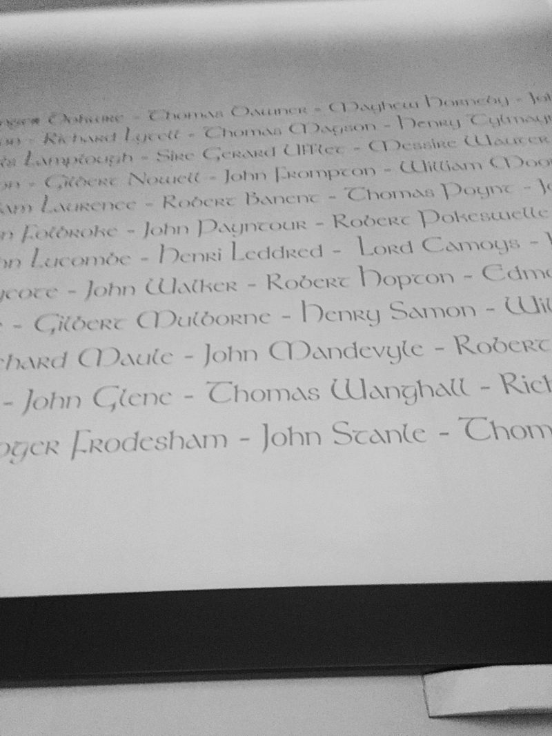

*What is shown in the source?*

This image shows a list of English Archers that were killed during the battle of Agincourt. This can be found at [The Battle of Agincourt Museum in France](https://www.bing.com/search?q=agincourt+museum&cvid=b4dfc59ac77b41ec8dc59babdff7f708&aqs=edge..69i57l2j69i59j69i64j69i11004.4530j0j1&FORM=ANAB01&DAF0=1&PC=U531).

*Who made it?*

The list was made by The Battle of Agincourt Museum in France, and the image was taken by a Wikipedia user called *Brookie*.

*Why was it made/Who was it for?*

It was most likely made as either a mural or an exhibit. It could either be something like an [ANZAC memorial](https://www.bing.com/images/search?view=detailV2&ccid=3BepN4Bo&id=670D26926068D79ADD326030E654CEA4B3881FA5&thid=OIP.3BepN4BoL52ZsvVR1R-3tAHaE7&mediaurl=https%3a%2f%2fexternal-preview.redd.it%2fzN3Cq2dclyY1xZMrR4-Wbhdm4aOvvMKRfL4pMn8qKUE.jpg%3fauto%3dwebp%26s%3d6b924adaf9ea011f6e8ce248fd8bf9f45aa710d9&exph=2400&expw=3609&q=Anzac+Memorial+Turkey&simid=608025506858474337&FORM=IRPRST&ck=AA3FBAE546A30B95AE45975B1CA0DFAA&selectedIndex=0&ajaxhist=0&ajaxserp=0), only less reverent. Otherwise, chances are it is there simply as an exhibit in the museum, providing nothing more than information.

*Is it historically accurate based on your information about the battle?*

It is, as despite winning, some English soldiers were killed. It isn’t outlandish to assume some of the English soldiers who were killed during battle were archers.